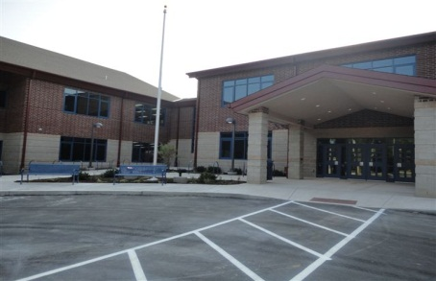
Welcome to Sam Adams Elementary School!! We are delighted to offer our students a state of the art building and education. Our elementary school services kindergarten through sixth grade students and offers a variety of educational opportunities.
Each classroom is equipped with an interactive white board, wireless capabilities, surround sound, doc camera and I Pads. The design of the classroom and furniture is made to enhance learning to its fullest capacity. With safety and security of our students and staff being a top priority, our building is equipped with the latest in surveillance cameras and building security systems.
The highly qualified staff at Sam Adams Elementary School uses data driven practices to teach our students. Children are enriched through such programs as STAR Early Literacy, Reading and Math, Accelerated Reading and Math, technology based Scholastic News, Starfall eBooks, and LCISD Gifted & Talented Programs.
Through Professional Development, staff has aligned the Common Core Standards to curriculum and district programs. NWEA, STAR, M-Step, Delta Math and DRA testing provide the data to drive instruction for student achievement. Staff is dedicated to providing the best educational opportunities to every child!
Sam Adams Elementary School is a MiBlSi building and provides structure and high expectations for all! Positive Behavior Initiatives and showing Ranger Pride are a part of our daily routine to promote good citizens. Our school is also supported by community members through TEAM, DARE and Anti-Bullying Programs.
To contact our office, please call 445.0517 or 228.5744. Breakfast is served from 7:20-7:45 a.m. Classes start for students at 7:45 a.m. and the tardy bell rings at 7:50 a.m. Students arriving after 8:15 a.m. are considered absent for the morning. End of the day dismissal is 3:11 p.m. Please notify the office before 2:30 p.m., if you are picking up your child at dismissal time. If you have any Transportation questions or concerns, please contact our Transportation Director at 445.0550.
The Sam Adams School Family looks forward to an educational and productive school year for your child!

